Exercise 8.1

1. The 3 ACF plot seem to be white noise because not enough of the lags are of bounds to say otherwise
2. The dashed blue lines indicate +-2 sqrt(T) where T is the length of the time series. So the difference in the dashed blue line in each of the graphs means that the length is shorter to longer

Exercise 8.2

1. The ggAcf plot function called on “ibmclose” data set produces this plot. All the lags are out of bounds.

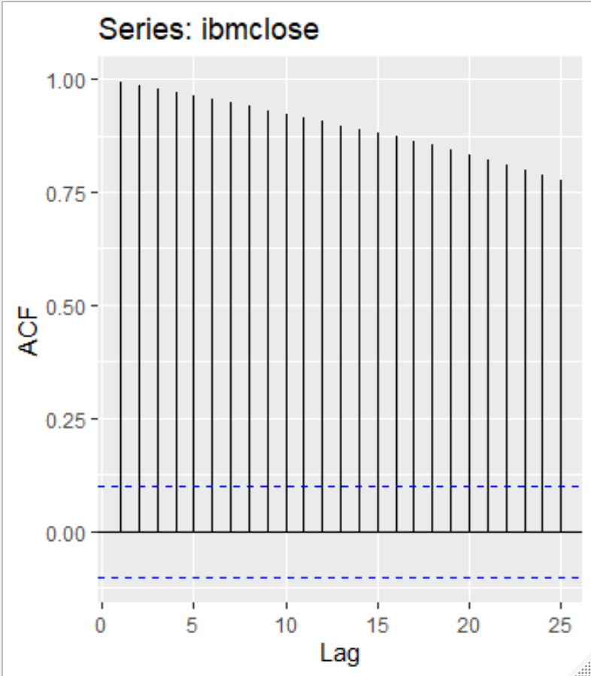

Differencing the above plot produced this plot below.

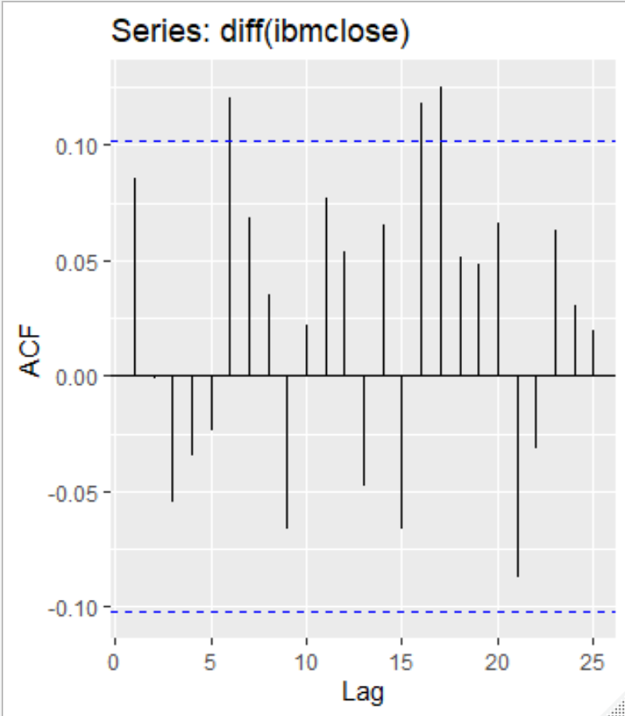

Then the PACF plot to produce the following plot. It looks like it does not need to be stationary because it only has one lag that is out of bounds, however since it is the very first one it hold more weight than any of the other ones and still requires differencing

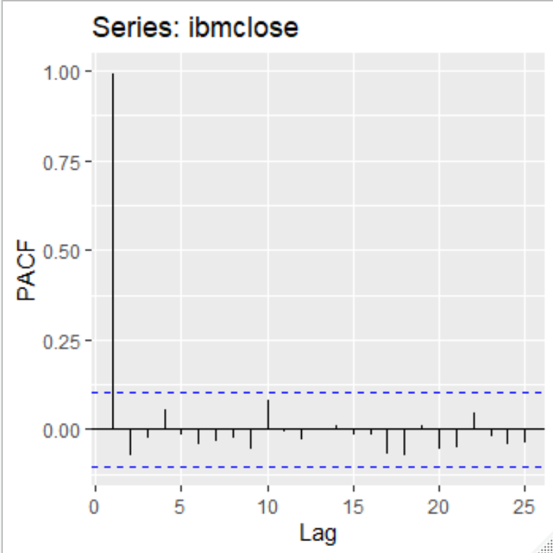

Then differencing the plot created the following

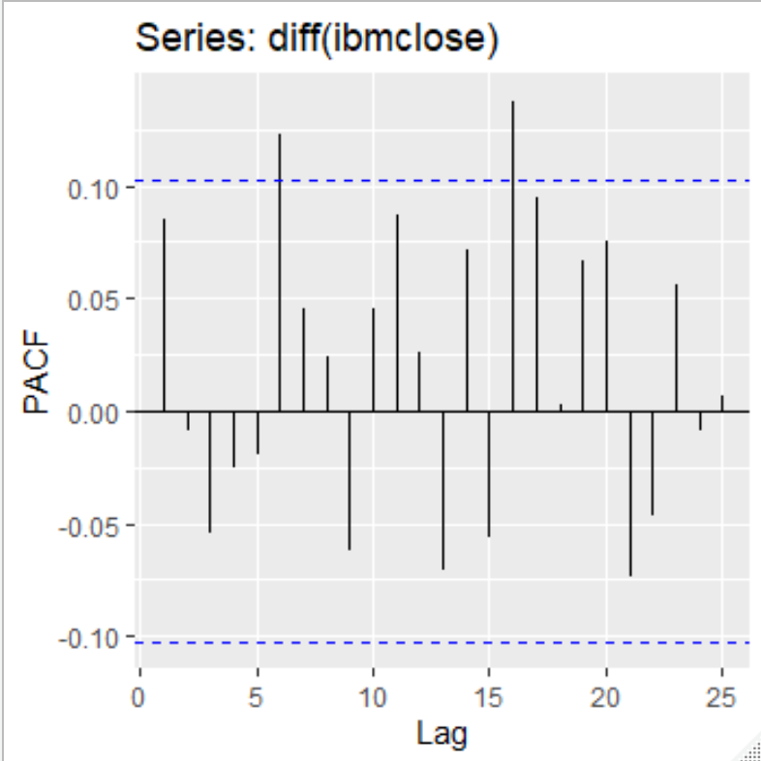

Exercise 8.3

1. The ggPacf(diff(usnetelec) produced the most stable plot
2. The ggPacf(diff(log(usgdp)) plot was the closest I could get to a stable plot
3. The ggPacf(log(diff(mcopper))) plot seems pretty stable with NaN’s produced
4. The ggPacf(diff(log(enplanements))) seems the best graph
5. The ggPacf(diff(log(visitors))) looks like the best graph